Gymnastics With Nikki

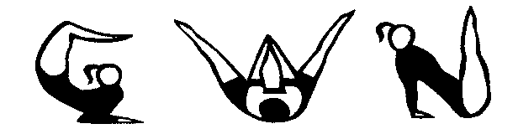

General Gymnastics For ALL Ages And Abilities!

Policy for Leaving Children before Classes &
Collecting Children after Classes
(Last Updated September 2020)

For More Information Please Contact:

Nikki Miller
Gymnastics With Nikki
186 Sandpiper Drive
Greenhills
East Kilbride
G75 8UW

Tel: 07793315826

Policy For Leaving Children Before Classes

POLICY FOR LEAVING GYMNASTS BEFORE CLASS

1) Before attending the gymnastics classes every time please ask yourself & your child these questions on the GWN Covid-19 Checklist for Coaches, Parents & Gymnasts.

2) Arrive on time, to limit cross over of classes coming/going out of the facility, wear a mask & observe social distancing rules.

3) Gymnast must wear a face mask in communal areas & will be checked in & go to the toilet & to wash their hands before going through to the hall where they can take off their mask & leave their belongings in a bag.

4) Please make sure that your child arrives in their gym wear, is not wearing any jewellery & that long hair is tied back in a bobble for safety reasons.

5) Please make sure that your child's gym wear is suitable clothing for taking part in gymnastics ie: Leotard, Shorts & T-Shirt or leggings. Tight and restrictive clothing like jeans will limit your child’s ability to perform.

6) Please remind your child to take off his/her socks for taking part in gymnastics or wears gymnastic shoes with a rubber sole.

7) Verrucas should be covered with a plaster to control cross infection.

8) Due to COVID-19 parents are encouraged to leave children at the main door & not be inside the building while the class is in progress unless:

* They need help with toilet/washing hands
* The child is under 5 years
* It is their first weeks of attending & still to settle in
* Feeling apprehensive or emotional

POLICY FOR PICKING GYMNASTS UP AFTER CLASS

1) Please come to the main door to pick up your child as no-one will be allowed to leave the premises by themselves unless you have organized otherwise eg: older gymnasts.

2) Gymnasts will wear a face mask & wash their hands before being checked out at the main door.

2) Senior coach will not leave the gym until ALL children have been collected.

3) Please make sure that your child has all their belongings with them when they leave, as left over water bottles will be disposed of due to possible contamination & likely cross infection.

4) For those classes training for 2 hours or more and who have brought a snack, please remove any rubbish and put it in the bin before leaving.

